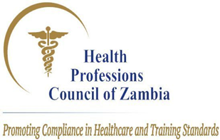

NOTICE TO STAKEHOLDERS
---------------------------------------------------------------------------------------------------
FERUARY/ MARCH 2024 PROFESSIONAL LICENSURE EXAMINATIONS CANDIDATES
------------------------------------------------------------------------------------------------------------ Following the release of the Health Professions Council of Zambia (HPCZ) Professional Licensure Examinations (LEX) February/March results on 28th March, 2024, it has come to our attention that there was a technical system error which resulted into swapping (switching) of the Theory and Practical paper results during the uploading process.
This however, has not affected the overall FINAL results for individual candidates. This technical system error has since been rectified and candidates are hereby advised to take the results on their portal as official results.
HPCZ sincerely apologies for the inconvenience this may have caused to all stakeholders and the candidates in particular.
Issued by the HPCZ Public Relations Unit.
E-mail: info@hpcz.org.zm
Customer Relations: +260770023624
6640 Mberere Road Olympia- Lusaka
Website: www.hpcz.org.zm
Health Professions Council of Zambia- HPCZ

Dated Thursday 4th April 2024, Lusaka.

